For Immediate Release—July 18, 2021
Link to totem pole journey photos, statement from All Pueblo Council of Governors are below.
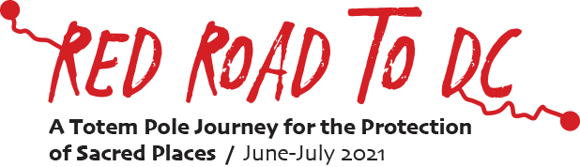
Pueblo and Diné leaders call on Biden to protect Greater Chaco Canyon

Tribes and Indigenous activists want no new oil and gas leases in sacred lands

Counselor, NM – Pueblo and Diné leaders and activists today hosted an event calling on President Biden to protect Greater Chaco Canyon and stop issuing new oil and gas leases in the sacred landscape.

In an event held as part of the Red Road to DC, a cross-country tour highlighting Indigenous sacred sites at risk, elected leaders and grassroots organizers urged Biden to take immediate action to stop the issue of new oil and gas leases in the Greater Chaco Region. Organizers of the Red Road tour stopped at the Counselor Chapter House in New Mexico to display a totem pole by Lummi Nation carvers to highlight sacred sites at risk due to development and infrastructure projects. They met with hosts from the Diné CARE, Native American Voters Alliance Education Project, All Pueblo Council of Governors, and the Pueblo Action Alliance.

"Chaco Canyon has been at the core of our organizing efforts for Pueblo Action Alliance,” said Julia Bernal, director of the Pueblo Action Alliance. “We have worked to raise awareness from the women, femme, and youth perspective on why it's important for us to protect cultural landscapes like the Greater Chaco region. The Greater Chaco region is our ancestral history, our modern Indigenous resistance, and our way to fight to plan our own futures.”

The Bureau of Land Management has proposed to permit 4,000 new wells and over 500 new drilling permits under the newly drafted Resource Management Plan in the ancestral homelands of the Navajo and Pueblo nations. The region is home to many of the sovereign nations’ cultural resources and sacred lands. More than 91% of the public lands surrounding the Chaco Canyon Cultural historic park are already occupied by energy companies under the federal fossil fuel leasing program.

“The fight to Protect Greater Chaco encompasses the fight against the climate crisis, the fight for inherent Tribal sovereignty, the fight against resource extraction and exploitation, and the fight to address the adverse health impacts on the communities who live in the region,” said Bernal.
###
Contact:
Brad Angerman, Pyramid Communications
bangerman@pyramidcommunications.com
702-218-4490
For additional information, photos, and a full list of tour stops for the Red Road Journey to DC, visit redroadtodc.org.
Photos: https://drive.google.com/drive/folders/1EDiXcyeF4Lnokr8la43leozion7LL_06?usp=sharing
Statement from the All Pueblo Council of Governors:
The All Pueblo Council of Governors (APCG), which represents the 20 Pueblo Nations of New Mexico and Texas, released a statement showing its support of the Red Road journey and saying it “maintains its priority and commitment to protect the Greater Chaco Region, the Bears Ears National Monument, and many other ancestral Puebloan sites in the American Southwest.”

APCG Statement: https://drive.google.com/file/d/15HBEC2BidY9ymS17nyrodh2vOz9SVI4P/view

